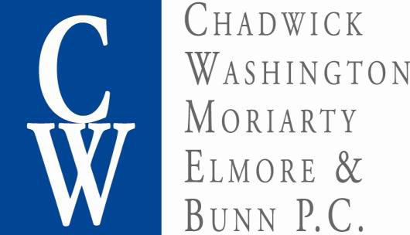

Collection Work Request Form

Please complete and fax or email to the paralegal assigned to your Association
or, if not known, then to mail@chadwickwashington.com or 703-352-5293.

Please attach an account statement for each property listed below.
If accounts contain violation charges (fines), please attach the notice/hearing letters.

Name of Community Association:

Date:

Does Association have any knowledge of any pending bankruptcy on any homeowner listed below? | Yes (please note on property below)  No

Does Association have any knowledge of any homeowner being in a military service? | Yes (please note on property below)  No
Do any accounts contain violation charges (fines)? | Yes (please note on property below)  No

Owner’s Name  (or former Owner) | Owner’s Phone Number | Property Address | Owner’s Mailing Address  (if different than property address) | Delinquent Amount  ($) | Comments / Requests / Info on employment, bank accounts, etc.

Owner’s Name  (or former Owner) | Owner’s Phone Number | Property Address | Owner’s Mailing Address  (if different than property address) | Delinquent Amount  ($) | Comments / Requests / Info on employment, bank accounts, etc.

